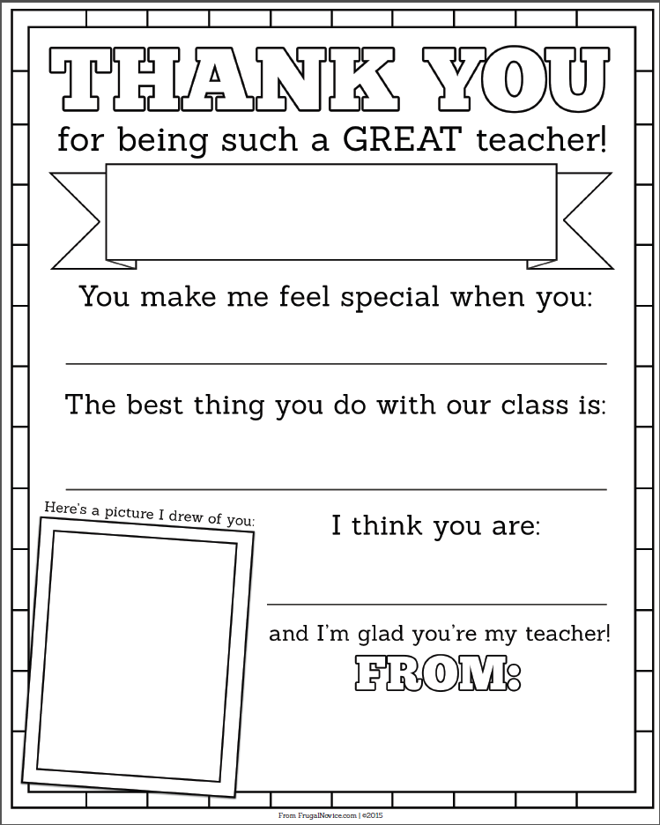

Type

Type

Type

Type

Mrs. Pickler